*Supplementary materials for*

**Global trends and local variations in land take per person**

Mengmeng Li1*, Peter H. Verburg1,2, Jasper van Vliet1

1 Institute for Environmental Studies, VU University Amsterdam, De Boelelaan 1085, 1081 HV Amsterdam, The Netherlands

2 Swiss Federal Research Institute WSL, Zürcherstrasse 111, CH-8903 Birmensdorf, Switzerland

* **Correspondence:** Mengmeng Li ([mengmeng.li@vu.nl](mailto:mengmeng.li@vu.nl))

**Citation:**

Li, M., Verburg, P.H., & van Vliet, J., 2022, Global trends and local variations in land take per person. Landscape and Urban Planning. <https://doi.org/10.1016/j.landurbplan.2021.104308>

Contents

1. Supplementary Methods 3

2. Supplementary Figures 4

3. Supplementary Tables 10

4. Supplementary References 14

# Supplementary Methods

To examine the impact of different ways of attributing new built-up land to changes in population and changes in BPC, we tested several options. In the main paper, we decompose the total change in built-up land into changes in population and changes in BPC, so that the multiplication of both equals the total change in built-up land. Here we explain three other methods of attributing changes in built-up land in order to assess the sensitivity for these attributions.

The first alternative is similar to the approach for attributing crop production change to either cropland expansion or yield increase, used for example in Eitelberg et al. (2016) and Wang et al. (2019). This approach could be relevant for SDG target 11.3, which states that the rate of increase in built-up land should not exceed the rate of increase in population, as it effectively takes the BPC in the starting year (${BPC}_{0}$) of each analysis period as the baseline. Specifically, the area of built-up land change in a given region due to changes in population ($A_{POP}$) and due to changes in BPC ($A_{BPC}$), respectively, can be calculated as:

$A_{POP}={BPC}_{0}×({POP}_{1}-{POP}_{0})$ (S1)

$A_{BPC}={POP}_{1}×({BPC}_{1}-{BPC}_{0})$ (S2)

Conversely, equations S3 and S4 use ${BPC}_{1}$ as a reference level, thereby effectively assuming that increased/decreased population individually consumes the same amount of built-up land in end year of this period:

$A_{POP}={BPC}_{1}×({POP}_{1}-{POP}_{0})$ (S3)

$A_{BPC}={POP}_{0}×({BPC}_{1}-{BPC}_{0})$ (S4)

Equations S5 and S6 use a reference level dependent on the direction of population change: increased population individually consumes the same amount of built-up land in end year of this period. In contrast, decreased population individually consumes the same amount of built-up land in starting year of this period.

$A_{POP}=f(BPC)×({POP}_{1}-{POP}_{0})$ (S5)

$A_{BPC}=f(POP)×({BPC}_{1}-{BPC}_{0})$ (S6)

Here, if ${POP}_{1}-{POP}_{0}≥0$, then $f\left(BPC\right)= {BPC}_{1}$, and $f\left(POP\right)= {POP}_{0}$; Otherwise, $f\left(BPC\right)= {BPC}_{0}$, and $f\left(POP\right)= {POP}_{1}$.

# Supplementary Figures

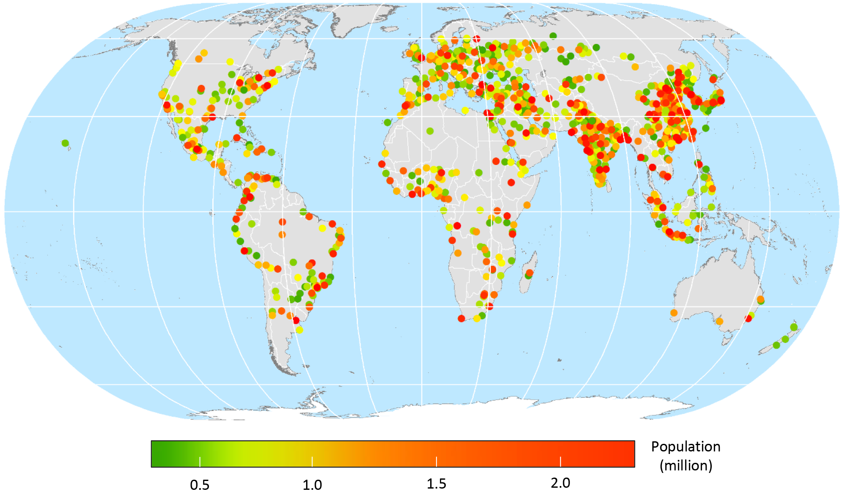

Figure S1. Distribution of cities with a population size large than 0.3 million.

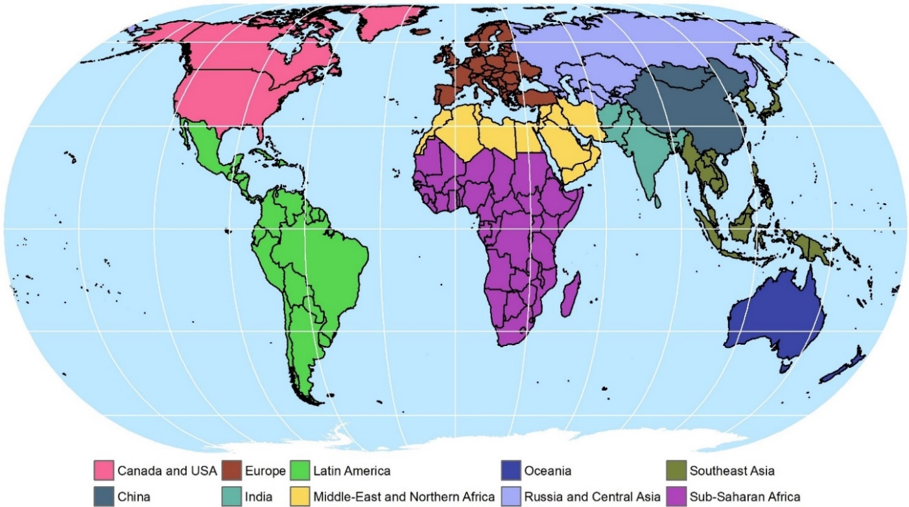

Figure S2. Ten world regions used in this article. Country boundaries are added for further spatial reference.

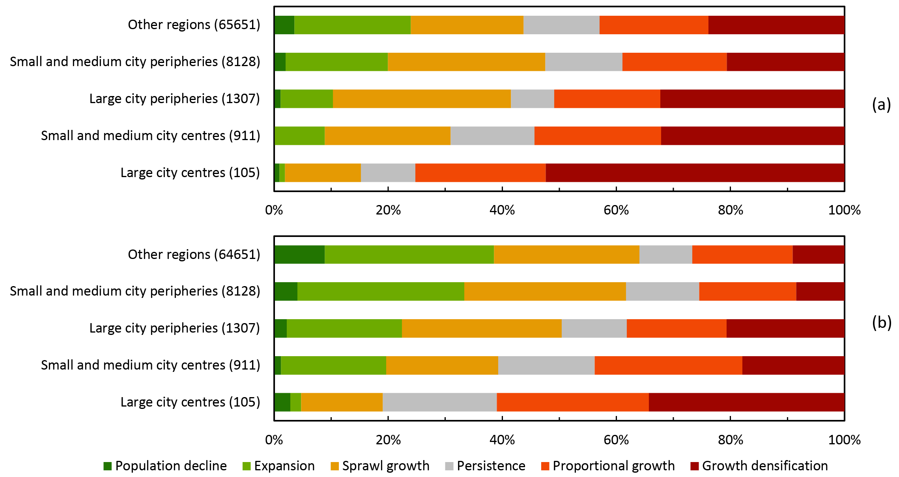

Figure S3. Distribution of built-up land change trajectories over the different types of regions for the periods a) 1975-1990, and b)1990-2000.

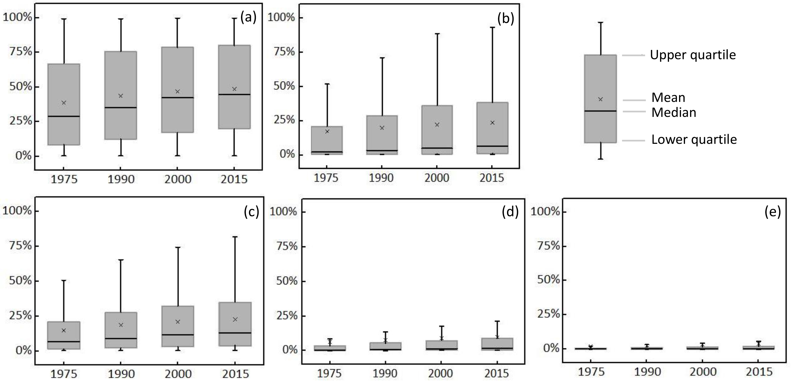

Figure S4. Percentage of built-up land to total available land in each region class. (a) large city centres; (b) large city peripheries; (c) small and medium city centres; (d) small and medium city peripheries; (e) other regions. Each boxplot is based on all regions that are classified as the specific region class, and average are taken over all regions within this class without weighing for their area of amount of built-up land. Calculations are based on the ~38 m GHSL dataset, in which water layers are excluded already.

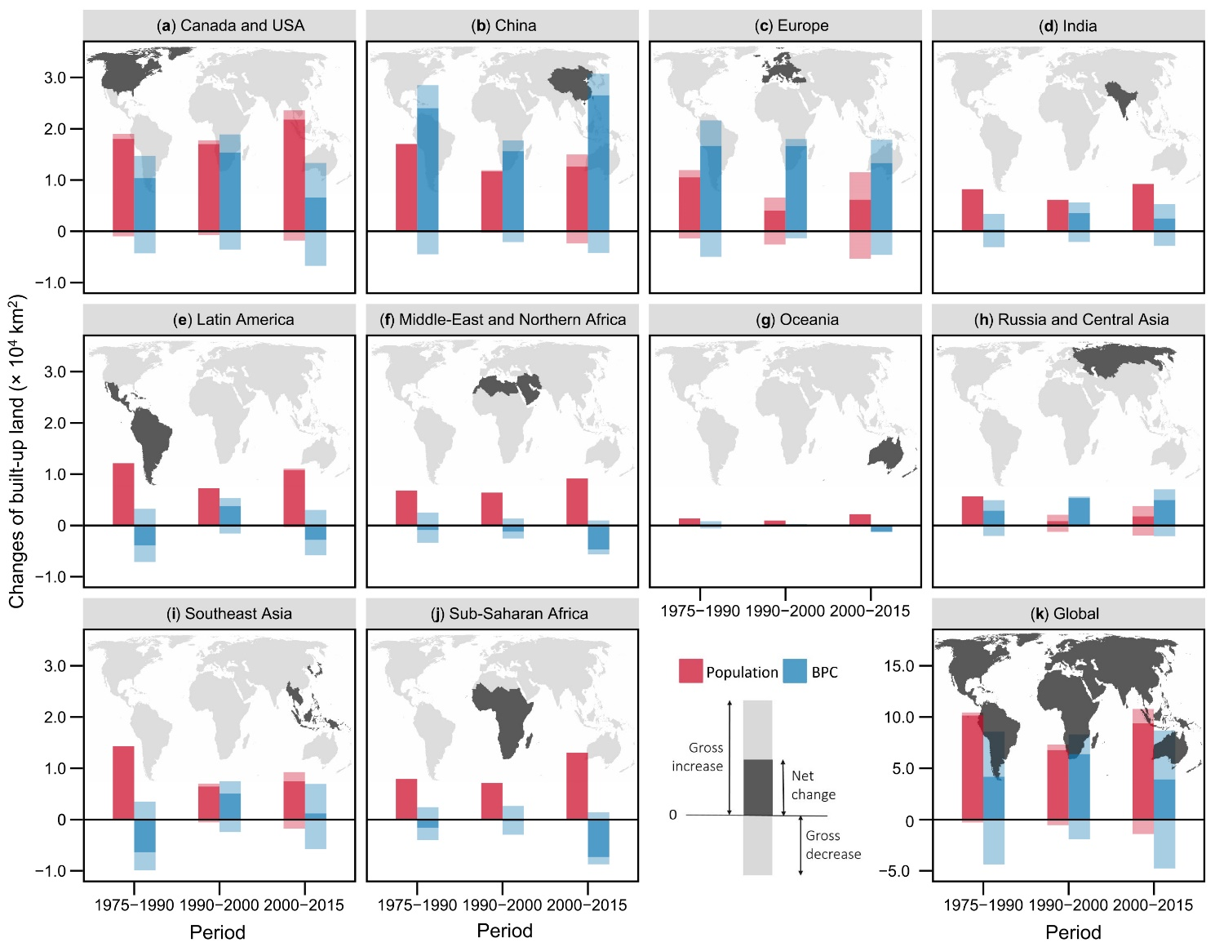

Figure S5. Heterogeneity in built-up land area changes. $A_{POP}$ and $A_{BPC}$ are calculated following equations (S1) and (S2).

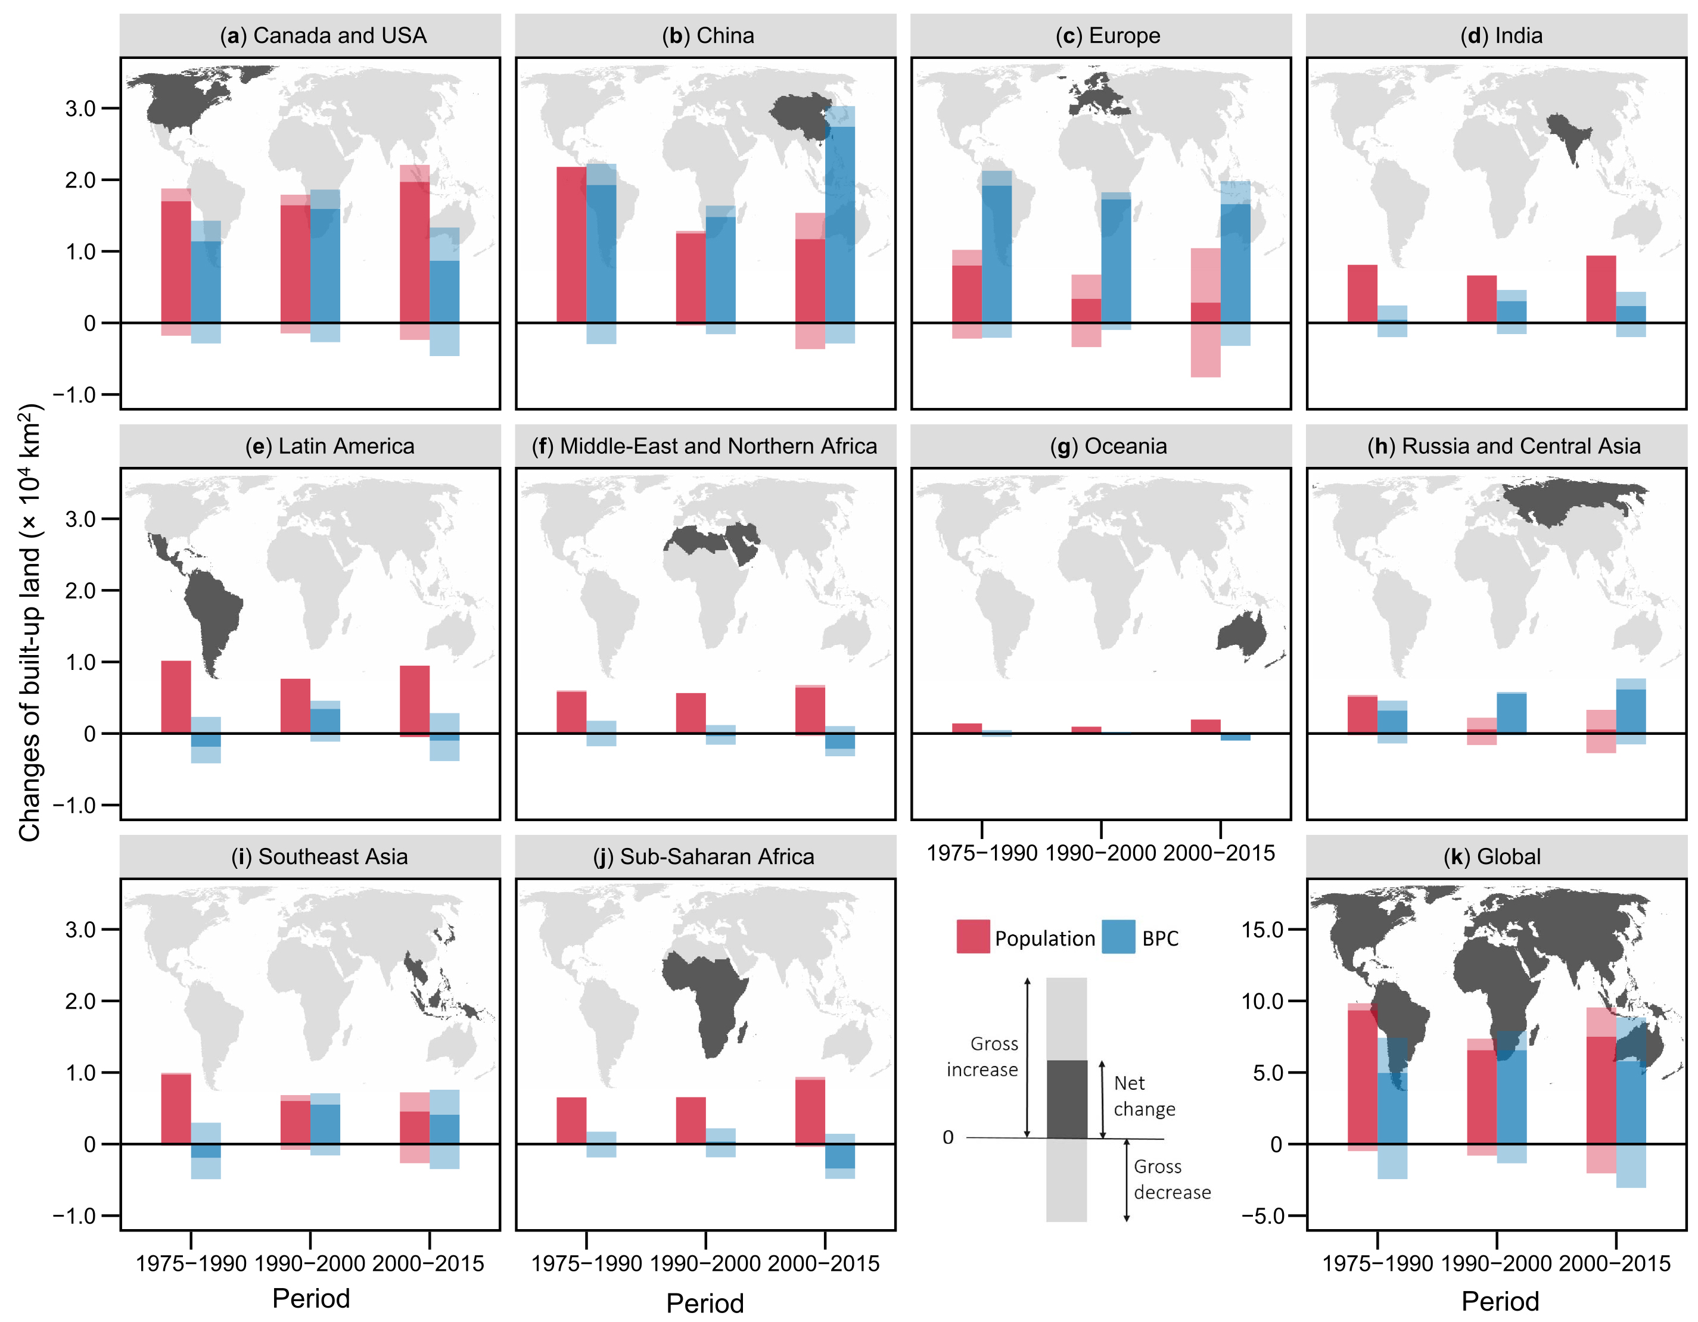

Figure S6. Heterogeneity in built-up land area changes. $A_{POP}$ and $A_{BPC}$ are calculated following equations (S3) and (S4).

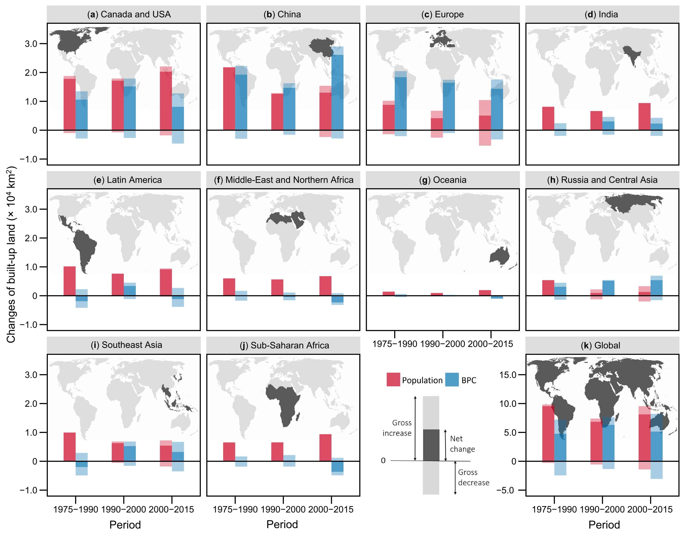

Figure S7. Heterogeneity in built-up land area changes. $A_{POP}$ and $A_{BPC}$ are calculated following equations (S5) and (S6).

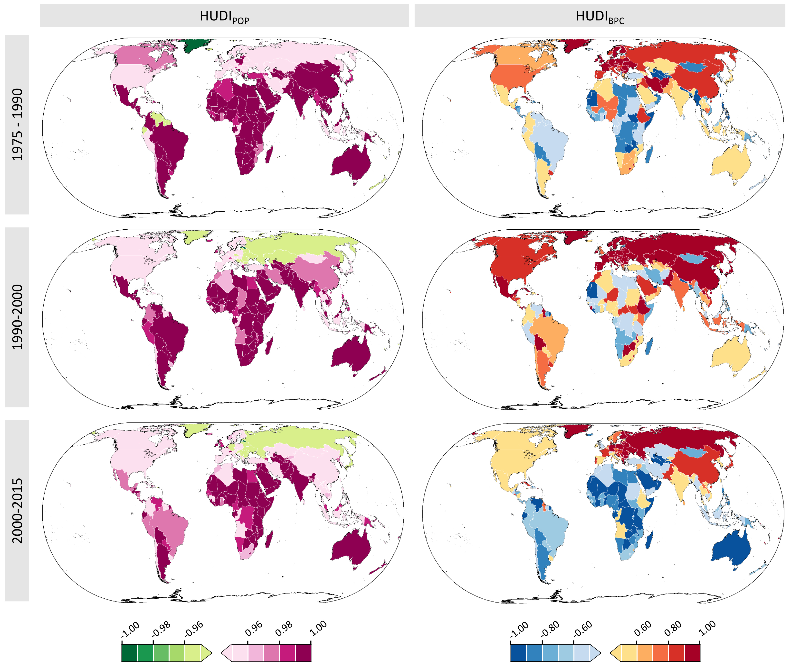

Figure S8. Homogeneity in built-up land change due to changes in population and due to changes in BPC within countries. Values closer to 1 or closer to -1 indicate that regions within a country all develop homogeneously, in terms of population dynamics or BPC changes, while values closer to 0 indicate more heterogeneous developments within a country.

# Supplementary Tables

Table S1. Analysis units for each country. For a full list of this table, please see the tabular file along with this supplementary material.

| **ID** | **Country/Region code** | **Country/Region name** | **Most detailed unit available** | **Mean population per Level-2 unit** | **Analysis unit** |
| --- | --- | --- | --- | --- | --- |
| 1 | ABW | Aruba | Level-0 | - | - |
| 2 | AFG | Afghanistan | Level-2 | - | Level-2 |
| 3 | AGO | Angola | Level-3 | 146573 | Level-2 |
| 4 | AIA | Anguilla | Level-0 | - | - |
| 5 | ALA | Åland | Level-1 | - | Level-1 |
| 6 | ALB | Albania | Level-3 | 78002 | Level-2 |
| 7 | AND | Andorra | Level-1 | - | Level-1 |
| 8 | ARE | United Arab Emirates | Level-3 | 42726 | Level-2 |
| 9 | ARG | Argentina | Level-2 | - | Level-2 |
| 10 | ARM | Armenia | Level-1 | - | Level-1 |
| 11 | ASM | American Samoa | Level-3 | 3281 | Level-2 |
| 12 | ATA | Antarctica | Level-0 | - | - |
| 13 | ATF | French Southern Territories | Level-1 | - | Level-1 |
| 14 | ATG | Antigua and Barbuda | Level-1 | - | Level-1 |
| 15 | AUS | Australia | Level-2 | - | Level-2 |
| 16 | AUT | Austria | Level-3 | 78228 | Level-2 |
| 17 | AZE | Azerbaijan | Level-2 | - | Level-2 |
| 18 | BDI | Burundi | Level-4 | 79857 | Level-2 |
| 19 | BEL | Belgium | Level-4 | 1025858 | Level-3 |
| 20 | BEN | Benin | Level-2 | - | Level-2 |
| 21 | BES | Bonaire, Sint Eustatius and Saba | Level-1 | - | Level-1 |
| 22 | BFA | Burkina Faso | Level-3 | 401781 | Level-3 |
| 23 | BGD | Bangladesh | Level-4 | 2248805 | Level-3 |
| 24 | BGR | Bulgaria | Level-2 | - | Level-2 |
| 25 | BHR | Bahrain | Level-1 | - | Level-1 |
| 26 | BHS | Bahamas | Level-1 | - | Level-1 |
| 27 | BIH | Bosnia and Herzegovina | Level-3 | 210094 | Level-3 |
| 28 | BLM | Saint-Barthélemy | Level-0 | - | - |
| 29 | BLR | Belarus | Level-2 | - | Level-2 |
| 30 | BLZ | Belize | Level-1 | - | Level-1 |
| 31 | BMU | Bermuda | Level-1 | - | Level-1 |
| 32 | BOL | Bolivia | Level-3 | 89685 | Level-2 |
| 33 | BRA | Brazil | Level-3 | 29478 | Level-2 |
| … | … | … | … | … | … |
| 256 | ZWE | Zimbabwe | Level-2 | - | Level-2 |

Table S2. Comparison of different approaches to allocating built-up land changes (in thousand km2) to changes in population and to changes in built-up land area per capita (BPC).

|  |  |  |  |  |  |  |  |  |  |  |  |  |
| --- | --- | --- | --- | --- | --- | --- | --- | --- | --- | --- | --- | --- |
| **Period** | **Equations (S1) and (S2)** | | **Equations (S3) and (S4)** | | **Equations (S5) and (S6)** | | **Equations (1) and (2)** | | **Mean** | | **S.D.** | |
| **APOP** | **ABPC** | **APOP** | **ABPC** | **APOP** | **ABPC** | **APOP** | **ABPC** | **APOP** | **ABPC** | **APOP** | **ABPC** |
| 1975-1990 | 101.46 (70.9%) | 41.70 (29.1%) | 93.43 (65.3%) | 49.74 (34.7%) | 95.46 (66.7%) | 47.71 (33.3%) | 88.22 (61.7%) | 54.77 (38.3%) | 94.64 (66.1%) | 48.48 (33.9%) | 5.48 (3.8%) | 5.41 (3.8%) |
| 1990-2000 | 67.70 (51.5%) | 63.87 (48.5%) | 65.96 (50.1%) | 65.61 (49.9%) | 68.43 (52.0%) | 63.14 (48.0%) | 66.14 (50.4%) | 65.21 (49.6%) | 67.12 (51.0%) | 64.46 (49.0%) | 1.15 (0.9%) | 1.16 (0.9%) |
| 2000-2015 | 93.71 (70.5%) | 39.13 (29.5%) | 74.98 (46.4%) | 57.86 (43.6%) | 81.33 (61.2%) | 51.51 (38.8%) | 83.05 (62.5%) | 49.58 (37.5%) | 83.27 (62.7%) | 49.58 (37.3%) | 7.78 (5.9%) | 7.78 (5.9%) |

Table S3. Built-up land and population for major world regions as well as their changes over time. For each world region, ‘Sum’ refers to the total built-up land area or population in the starting year, or their total changes. Similarly, ‘Mean’ represents the average built-up land area or population per subdivision in the starting year, or their average changes per subdivision for corresponding world region. As indicated, mean values for nearly all world regions are significantly different from the mean of the entire regions combined (two-tailed t-test, **p<0.01, *p<0.05).

|  |  |  |  |  |  |  |  |  |  |
| --- | --- | --- | --- | --- | --- | --- | --- | --- | --- |
| **Period** | **World region** | **Built-up land in the starting year [km2]** | | **New built-up land [km2]** | | **Population in the starting year [million]** | | **Population change [million]** | |
| **Sum** | **Mean** | **Sum** | **Mean** | **Sum** | **Mean** | **Sum** | **Mean** |
| 1975-1990 | Canada and USA | 86965 | 25** | 28386 | 8** | 242 | 0.07** | 38 | 0.01** |
| China | 47651 | 17** | 41050 | 15** | 939 | 0.34** | 252 | 0.09** |
| Europe | 95541 | 5 | 27187 | 1** | 580 | 0.03** | 44 | 0.00** |
| India | 18411 | 5 | 8534 | 2* | 801 | 0.20** | 333 | 0.08** |
| Latin America | 27067 | 2** | 8030 | 1* | 330 | 0.03** | 114 | 0.01** |
| Middle-East and Northern Africa | 12334 | 3** | 5815 | 2* | 168 | 0.05** | 79 | 0.02** |
| Oceania | 6252 | 8** | 1553 | 2 | 17 | 0.02** | 4 | 0.00** |
| Russia and Central Asia | 27055 | 9** | 8330 | 3** | 184 | 0.06* | 30 | 0.01** |
| Southeast Asia | 40095 | 3** | 7792 | 1** | 469 | 0.04** | 148 | 0.01** |
| Sub-Saharan Africa | 13694 | 1** | 6311 | 1** | 349 | 0.03** | 172 | 0.01** |
| 1990-2000 | Canada and USA | 115351 | 33** | 32380 | 9** | 280 | 0.08* | 35 | 0.01 |
| China | 88701 | 32** | 27299 | 10** | 1191 | 0.43** | 117 | 0.04** |
| Europe | 122728 | 6** | 20631 | 1** | 624 | 0.03** | 16 | 0.00** |
| India | 26945 | 7 | 9662 | 2** | 1134 | 0.29** | 253 | 0.06** |
| Latin America | 35097 | 3** | 10962 | 1** | 444 | 0.03** | 80 | 0.01** |
| Middle-East and Northern Africa | 18149 | 5** | 5119 | 1** | 247 | 0.07 | 71 | 0.02** |
| Oceania | 7805 | 10** | 1034 | 1 | 21 | 0.03** | 3 | 0.00** |
| Russia and Central Asia | 35386 | 12** | 6158 | 2* | 214 | 0.07 | 3 | 0.00** |
| Southeast Asia | 47887 | 4** | 11534 | 1** | 617 | 0.05** | 95 | 0.01** |
| Sub-Saharan Africa | 20005 | 2** | 6816 | 1** | 521 | 0.04** | 159 | 0.01** |
| 2000-2015 | Canada and USA | 147731 | 42** | 28386 | 8** | 315 | 0.09 | 41 | 0.01** |
| China | 116000 | 42** | 39120 | 14** | 1308 | 0.47** | 99 | 0.04** |
| Europe | 143359 | 7** | 19431 | 1** | 640 | 0.03** | 29 | 0.00** |
| India | 36607 | 9 | 11672 | 3** | 1386 | 0.35** | 354 | 0.09** |
| Latin America | 46060 | 4** | 7985 | 1** | 524 | 0.04** | 107 | 0.01** |
| Middle-East and Northern Africa | 23268 | 6** | 4269 | 1** | 318 | 0.09 | 103 | 0.03** |
| Oceania | 8840 | 11* | 1066 | 1 | 24 | 0.03** | 6 | 0.01** |
| Russia and Central Asia | 41544 | 14** | 6721 | 2** | 217 | 0.07* | 10 | 0.00** |
| Southeast Asia | 59420 | 4** | 8649 | 1** | 712 | 0.05** | 118 | 0.01** |
| Sub-Saharan Africa | 26821 | 2** | 5559 | 0** | 680 | 0.06** | 319 | 0.03** |

Table S4. BPC and relative changes in built-up land, population, and BPC for ten major world regions. For large parts of the world regions, BPC in the starting year, annual built-up land change, annual population change, and annual BPC change are significantly different from these for all world regions combined (two-tailed t-test, **p<0.01, *p<0.05).

|  |  |  |  |  |  |
| --- | --- | --- | --- | --- | --- |
| **Period** | **World region** | **BPC in the starting year [m2/person]** | **Δ Built-up land** | **Δ Population** | **Δ BPC** |
| 1975-1990 | Canada and USA | 359** | 1.90%** | 0.97%** | 0.92%** |
| China | 51** | 4.23%** | 1.60%** | 2.59%** |
| Europe | 165** | 1.68%** | 0.49%** | 1.19%** |
| India | 23** | 2.57%** | 2.34%** | 0.22%** |
| Latin America | 82** | 1.75%** | 1.99% | -0.24%** |
| Middle-East and Northern Africa | 73* | 2.61%** | 2.59%** | 0.01%** |
| Oceania | 361** | 1.49%** | 1.29%** | 0.19% |
| Russia and Central Asia | 147 | 1.81%** | 1.00%** | 0.80%* |
| Southeast Asia | 85** | 1.19%** | 1.84%** | -0.64%** |
| Sub-Saharan Africa | 39** | 2.56%** | 2.70%** | -0.14% |
| 1990-2000 | Canada and USA | 412** | 2.51%** | 1.20% | 1.29%** |
| China | 74** | 2.72% | 0.94%** | 1.76%** |
| Europe | 197** | 1.57%** | 0.25%** | 1.31%** |
| India | 24** | 3.11%** | 2.03%** | 1.06%** |
| Latin America | 79** | 2.76%** | 1.66% | 1.07%** |
| Middle-East and Northern Africa | 73** | 2.52%** | 2.55%** | -0.03%** |
| Oceania | 371** | 1.25%** | 1.16% | 0.09%** |
| Russia and Central Asia | 166** | 1.62%** | 0.15%** | 1.46%** |
| Southeast Asia | 78** | 2.18%** | 1.44%** | 0.73%** |
| Sub-Saharan Africa | 38** | 2.98%** | 2.71%** | 0.26%** |
| 2000-2015 | Canada and USA | 469** | 1.18%** | 0.83%** | 0.35%** |
| China | 89** | 1.96%** | 0.49%** | 1.46%** |
| Europe | 224** | 0.85%** | 0.29%** | 0.56%** |
| India | 26** | 1.86%** | 1.53%** | 0.33%** |
| Latin America | 88** | 1.07% | 1.24%* | -0.17% |
| Middle-East and Northern Africa | 73** | 1.13%* | 1.89%** | -0.75%** |
| Oceania | 375** | 0.76% | 1.43%** | -0.66%** |
| Russia and Central Asia | 192** | 1.00%** | 0.30%** | 0.70%** |
| Southeast Asia | 83** | 0.91% | 1.03%** | -0.11%** |
| Sub-Saharan Africa | 39** | 1.26%** | 2.60%** | -1.30%** |

# Supplementary References

Eitelberg, D. A., van Vliet, J., Doelman, J. C., Stehfest, E., Verburg, P. H., 2016, Demand for biodiversity protection and carbon storage as drivers of global land change scenarios, *Global Environmental Change* **40:**101-111. <https://doi.org/10.1016/j.gloenvcha.2016.06.014>

Wang, Y., van Vliet, J., Pu, L., Verburg, P. H., 2019, Modeling different urban change trajectories and their trade-offs with food production in Jiangsu Province, China, *Computers, Environment and Urban Systems* **77:**101355. <https://doi.org/10.1016/j.compenvurbsys.2019.101355>